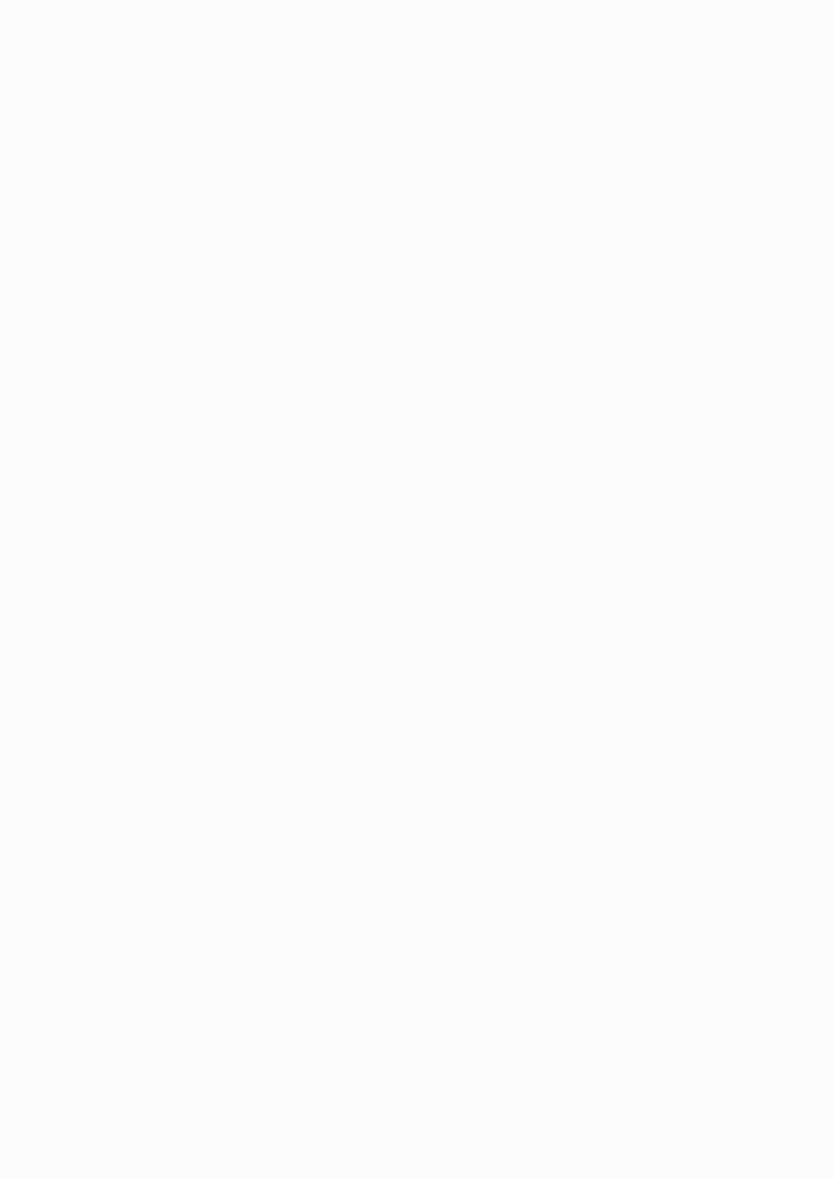
ZonoFit — Final MVP Gym Owner Portal PRD
1. Purpose
The ZonoFit Gym Owner Portal is a simple web app for partner gyms.
Its purpose is to let the gym owner:
- See ZonoFit activity at their gym
- Verify and monitor gym visits
- See active ZonoFit members
- See membership and visit information
- See revenue generated through ZonoFit
- See additional-visit revenue
- Check settlement status
- Access their gym QR
- Receive important operational alerts
The portal must remain simple.
It is not a CRM, full gym-management software,
accounting software, or staff-management system.

───

2. Final MVP Navigation
The portal should contain only:
- Dashboard
- Visits
- Members
- Revenue & Settlements
- Gym Profile
- Support
There should be no separate notification center in the MVP.
Important alerts should appear directly where the owner needs to see them.

───

3. Dashboard
The Dashboard is the main screen.
The owner should be able to understand the current situation of the gym within a few seconds.
Dashboard Header
Show:
- Gym name
- Gym status
- Current date
Example:
XYZ Fitness
ZonoFit Partner · Active

───

4. Dashboard Summary Cards
The dashboard should show:
Today's ZonoFit Visits
Example:
18
Number of successfully recorded ZonoFit visits today.

───

Active ZonoFit Members
Example:
47
Number of users currently having an active ZonoFit membership associated with this gym.
───

Today's Additional Visits
Example:
6
Number of visits beyond the applicable included/mandatory visit allocation that are generating additional revenue for the gym.

───

Today's Revenue
Example:
₹1,250
Revenue generated for the gym through ZonoFit today according to the settlement calculation.

───
5. Date-Based Revenue
The owner should be able to view revenue for a selected date range.
The dashboard should provide:
Revenue Period
with:
- Start Date
- End Date
- Apply
Example:
From: 1 September 2026
To: 7 September 2026
Then show:
Total ZonoFit Revenue
₹8,450
Membership Revenue
₹6,500
Additional Visit Revenue
₹1,950
Total ZonoFit Visits
82
Additional Visits
13
This gives the owner a simple understanding of how much ZonoFit generated for their gym during that period.

───

6. Additional Visit Revenue
This is an important part of the MVP.
The owner should be able to see revenue
generated from visits beyond the applicable included/mandatory visit allocation.
Example:
Additional Visits: 13
Revenue from Additional Visits: ₹1,950
The system should calculate this automatically based on the commercial terms configured by ZonoFit.
The gym owner should not manually calculate or enter the amount.

───

7. Revenue Breakdown
For a selected date range, show:
Metric | Value
Total Visits | 82
Included/Mandatory Visits | 69
Additional Visits | 13
Membership Revenue | ₹6,500
Additional Visit Revenue | ₹1,950
Total Revenue | ₹8,450

The exact calculation should always come from the ZonoFit backend.

───

8. Revenue Date Examples
The owner can select:
Today
13 Sep – 13 Sep
Yesterday
12 Sep – 12 Sep
This Week
7 Sep – 13 Sep
This Month
1 Sep – 13 Sep
Custom Range
Example:
1 Sep – 10 Sep
The owner should be able to select any valid start and end date.

───

9. Visits Page
The Visits page shows all ZonoFit visits associated with the gym.
Each visit should show:
- User name
- Date
- Time
- Visit status
- Verification method
- Visit type
- Revenue category, where applicable
Example:

User | Date | Time | Status | Type
Rahul | 13 Sep | 7:30 PM | Verified | Included
Aman | 13 Sep | 8:10 PM | Verified | Additional
Rohan | 13 Sep | 8:30 PM | Verified | Included

───

10. Visit Types
A visit should clearly identify whether it is:
Included Visit
Visit covered under the user's applicable membership/mandatory visit structure.
Additional Visit
Visit beyond the applicable included allocation and therefore eligible for additional gym revenue according to the commercial agreement.
This distinction is important for the gym owner.

───

11. Visit Filters
The owner should be able to filter visits by:
- Date
- User
- Visit status
- Visit type
Date filter should support:
- Today
- This Week
- This Month
- Custom Date Range

───

12. Visit Status
Possible statuses:
- Booked
- Verified
- Pending
- Cancelled
- Rejected
- Completed
The normal successful QR check-in should automatically become:
Verified
The gym owner should not have to manually approve every normal visit.

───

13. QR Check-In
Each partner gym receives a ZonoFit QR code.
The QR is linked specifically to that gym.
When a user scans the QR:
- ZonoFit identifies the gym.
- ZonoFit checks the user's booking/membership.
- ZonoFit verifies the visit according to the verification rules.
- The visit is recorded.
- The gym dashboard updates.
The gym owner should be able to access the QR from:
Gym Profile → ZonoFit QR
Actions:
- View QR
- Download QR
- Print QR

───
14. QR Problem / Gap Alert
If there is a problem with the QR/check-in system, the gym owner should be alerted directly.
Examples:
QR Not Working
Action Required
Your ZonoFit QR is currently not working correctly. Please contact ZonoFit Support.
QR Deactivated
Action Required
Your current ZonoFit QR has been deactivated. Please use the newly issued QR.
Verification Issue
Action Required
A ZonoFit visit could not be automatically verified.
These alerts should appear prominently on the Dashboard.
There should be no need for the owner to open a separate notification page.

───

15. Emergency / Action Required Alerts
Only important alerts should interrupt the normal dashboard experience.
Examples:
- QR not working
- QR deactivated
- Settlement failure
- Verification system issue
- Gym temporarily suspended
- Important ZonoFit operational issue
Normal events should not create unnecessary
notifications.
For example:
Do NOT show:
"Rahul checked in."
as a notification.
That information already appears in the Visits/Dashboard section.

───

16. Members Page
The Members page shows users currently associated with the gym through ZonoFit.
Each member should show:
- User name
- Membership status
- Membership start date
- Membership expiry date
- Visits completed
- Mandatory visits
- Last visit
Example:

───

17. Member Details
Opening a member shows only information relevant to the gym.
Show:
Member | Status | Expiry | Visits | Mandatory
Rahul | Active | 25 Sep | 8 | 10
Aman | Active | 30 Sep | 5 | 10
Member
- Name
- ZonoFit Member ID
Membership
- Gym membership status
- Start date
- Expiry date
Visits
- Current membership visits
- Mandatory visits
- Completed visits
- Remaining applicable visits
- Last visit
Visit History
Show recent visits with:
- Date
- Time
- Status
- Verification method

───

18. Do Not Show User Wallet Details
The gym owner does not need access to the user's:
- Credit wallet balance
- INR wallet balance
- Product purchases
- Personal financial information
- Other-gym activity
- Payment methods
The gym should only receive information necessary to operate the ZonoFit partnership.

───

19. Revenue & Settlements Page
This page should have two simple sections:
Revenue
Shows revenue generated through ZonoFit.
Settlements
Shows what has been paid to the gym.

───

20. Revenue Section
The owner can select a date range.
Example:
1 September – 7 September
Show:
Total Revenue: ₹8,450
Breakdown:
Membership Revenue: ₹6,500
Additional Visit Revenue: ₹1,950
And:
Total Visits: 82
Additional Visits: 13

───

21. Settlement Section
Show:
Pending Settlement
₹8,450
Already Settled
₹32,500
Last Settlement
₹7,200 · 7 Sep 2026
Settlement Status
Settled
or:
Pending
or:
Failed

───

22. Settlement History
The owner can see previous settlement records.
Each record should contain:
- Settlement date
- Settlement period
- Amount
- Status
- Settlement ID
Example:

───

23. Gym Profile
The Gym Profile page contains basic gym
Period | Amount | Status
1–7 Sep | ₹8,450 | Settled
25–31 Aug | ₹6,800 | Settled
18–24 Aug | ₹7,150 | Settled
information.
Show:
- Gym name
- Address
- Contact number
- Owner/contact name
- Operating hours
- Gym status
- ZonoFit partnership status

───

24. Gym QR
Inside Gym Profile:
ZonoFit Check-In QR
The owner can:
- View QR
- Download QR
- Print QR
The QR must belong specifically to that gym.
The owner cannot manually create or edit the QR.

───

25. Support
The Support page should provide:
- ZonoFit support contact
- QR issue support
- Visit verification support
- Settlement/payment support
- Partnership support
The owner can report an issue if required.

───
26. No Notification Page
The MVP should not have a separate notification center.
Instead:
Important alerts appear on the Dashboard.
Example:
⚠️ Action Required
Your ZonoFit QR is not responding. Please contact support.
Once the issue is resolved, the alert disappears.
This keeps the web app clean.

───

27. Final Dashboard Layout
The final Dashboard should roughly follow this structure:
XYZ FITNESS
ZonoFit Partner · Active

───

Overview
Today's Visits
18
Active Members
47
Additional Visits
6
Today's Revenue
₹1,250

───

Revenue
Select Period
From: 01/09/2026
To: 07/09/2026
Total Revenue
₹8,450
Membership Revenue
₹6,500
Additional Visit Revenue
₹1,950
Total Visits
82
Additional Visits
13

───

Recent Visits
Rahul Sharma — 9:42 AM — Verified — Included
Aman Mehta — 10:15 AM — Verified — Additional
Rohan Jain — 11:05 AM — Verified — Included
───

Action Required
Only show this section when something genuinely requires attention.
Example:
QR Issue Detected
Your current ZonoFit QR may not be working correctly. Contact ZonoFit Support.
If there is nothing requiring attention:
Do not show the section.

───

28. Final MVP Navigation
The portal navigation should be:
Dashboard
Visits
Members
Revenue & Settlements
Gym Profile
Support
That's it.

───

29. MVP Principle
The gym owner should be able to answer these questions immediately:
"How many ZonoFit people came today?"
→ Dashboard
"Who came?"
→ Visits
"How many ZonoFit members do I have?"
→ Members
"How much money did ZonoFit generate?"
→ Revenue
"How much came from additional visits?"
→ Revenue → Additional Visit Revenue
"What did I earn between two dates?"
→ Revenue → Custom Date Range
"Has ZonoFit paid me?"
→ Settlements
"Is my QR working?"
→ Gym Profile / Action Required alert
"Is there something wrong?"
→ Dashboard → Action Required
The portal should stay this simple for MVP. No CRM, no unnecessary analytics, no notification
inbox, and no complicated gym-management features.

